**2015 Leaving Cert Physics Paper (Ordinary Level)**

**2015 no.1**

A student carried out an experiment to investigate the relationship between force and acceleration by applying a force to a body and measuring the resulting acceleration.

The table shows measurements recorded during the experiment.

|  |  |  |  |  |  |  |  |
| --- | --- | --- | --- | --- | --- | --- | --- |
| Force (N) | 0.5 | 1.0 | 1.5 | 2.0 | 2.5 | 3.0 | 3.5 |
| Acceleration (m s−2) | 0.1 | 0.2 | 0.3 | 0.4 | 0.5 | 0.6 | 0.7 |

1. Draw a labelled diagram of the apparatus used in the experiment.
2. State what measurements were taken during the experiment.
3. How were the effects of friction reduced in this experiment?
4. Plot a graph, on graph paper, of the acceleration against the force.
5. What does your graph tell you about the relationship between the acceleration of the body and the force applied to it?

**2015 no.2**

During an experiment to measure the specific latent heat of vaporisation of water, cold water was placed in an insulated copper calorimeter. Dry steam was passed into the water, causing the temperature of the calorimeter and water to rise. The following are some of the measurements that were recorded.

Mass of calorimeter + water .......................................................... 90.7 g

Mass of calorimeter + water + steam ............................................ 92.3 g

1. Draw a labelled diagram of the apparatus used in the experiment.
2. How was the steam dried?
3. What other measurements should be taken during this experiment?
4. Calculate the mass of steam used.
5. Calculate the latent heat released when the steam condensed.
6. State one safety precaution required for this experiment.

(specific latent heat of vaporisation of water = 2.3 × 106 J kg−1)

**2015 no.3**

In an experiment to measure the focal length of a concave mirror, a student placed an object in front of the mirror so that a real image was formed. The student repeated the experiment by placing the object at different positions.

The table shows the data recorded by the student.

|  |  |  |  |  |
| --- | --- | --- | --- | --- |
| *u* (cm) | 20 | 25 | 30 | 60 |
| *v* (cm) | 60 | 38 | 30 | 19.5 |

1. Draw a labelled diagram showing the arrangement of the apparatus used.
2. How was the position of the image located?
3. Show the distances *u* and *v* on your diagram.
4. Calculate the value of *f*, the focal length of the mirror.
5. Why did the student repeat the experiment?

**2015 no.4**

In an experiment to find the resistivity of the material of a wire, a student took a sample of the wire and measured its length *l*, diameter *d*, and resistance *R*.

1. Describe how the student found the resistance of the wire.
2. What instrument did the student use to measure the diameter of the wire?

The table shows the measurements recorded by the student.

|  |  |  |
| --- | --- | --- |
| *R*/Ω | 30 |  |
| *l*/cm | 80 |  |
| *d*/mm | 0.21 | 0.26 | 0.22 |

1. Use the data to calculate the cross-sectional area of the wire.
2. Find the resistivity of the material in the wire.
3. State two precautions which should be taken in order to obtain an accurate result.

**2015 no.5**

Answer any **eight** of the following parts, (*a*), (*b*), (*c*), etc.

1. State Newton’s law of universal gravitation.
2. A small stone is thrown straight up from the ground with an initial speed of 20 m s−1.

Calculate the height it has reached after two seconds.

(acceleration due to gravity, *g* = 9.8 m s−2)

1. From the list below, identify (*i*) the scientist associated with the law of refraction of light and (*ii*) the scientist associated with the laws of electromagnetic induction.

**Faraday Snell Joule Archimedes**

1. 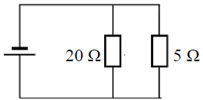A glass block has a critical angle of 42°.

Calculate the refractive index of the glass used in the block.

1. Calculate the effective resistance of the resistors shown in this circuit diagram.
2. 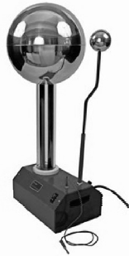State Boyle’s law.
3. State one use of the device shown on the right.
4. Name an electronic component that has a p-n junction.
5. What is the purpose of a transformer in a mobile phone charger?
6. What is meant by the *half-life* of a radioactive substance?

**2015 no.6**

1. Define potential energy.
2. 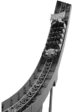Define kinetic energy.
3. State the principle of conservation of energy.
4. Explain how the principle applies to a roller-coaster.

A roller-coaster car of mass 850 kg is released from rest at point A of the track, as shown in the diagram.

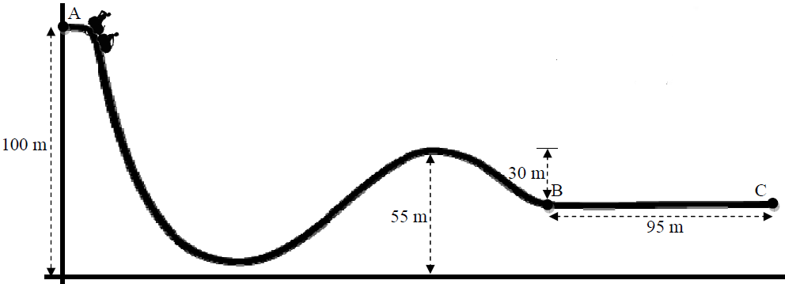

1. Calculate the difference in height between point A and point B.
2. Calculate the change in the potential energy of the car between A and B.
3. Write down the kinetic energy of the car at point B, assuming there is no friction and no air resistance.
4. Calculate its velocity at point B.
5. The brakes are applied at point B and the car comes to a stop at point C.

Calculate the deceleration of the car between B and C.

1. Calculate the average force required to bring the car to a stop.

(acceleration due to gravity, *g* = 9.8 m s−2)

**2015 Question 7**

1. Explain the term *resonance*.
2. Describe a laboratory experiment to demonstrate resonance.

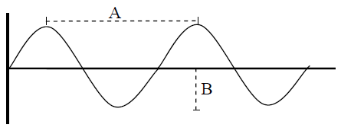

The diagram shows a waveform.

1. What is length A called?
2. What is length B called?
3. What is meant by the frequency of a wave?
4. List three characteristics of a musical note.
5. What is meant by the term *natural frequency of an object*?
6. The natural frequency of a stretched string is 250 Hz.

Calculate the wavelength of the sound wave produced.

(speed of sound in air *=* 340 m s−1)

**2015 Question 8**

1. Define capacitance. Name the unit of capacitance.

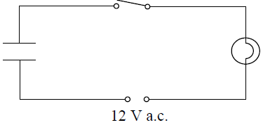

1. The diagram above shows a circuit with a bulb, switch, capacitor and a 12 V a.c. power supply.

What is observed when the switch is closed?

1. What would be observed if a 12 V d.c. supply were used instead of the a.c. supply?
2. What do these observations tell us about capacitors?
3. The capacitor has a charge of 0.8 C when connected to the 12 V d.c. supply.

Calculate its capacitance.

1. Describe an experiment to show that energy is stored in a charged capacitor.

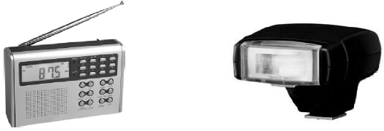

1. The photographs show a radio and a camera flash. Each of these devices makes use of a property of capacitors. Name the property used in each case.

**2015 Question 9**

1. Distinguish between heat and temperature.

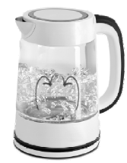

The diagram shows a kettle which is filled with 500 g of water which is initially at a temperature of 20 °C.

The heating element of the kettle has a power rating of 0.8 kW.

We assume all the heat is transferred to the water.

1. Find the energy required to raise the temperature of the water to 100 °C.
2. What is the energy supplied by the element per second?
3. How long will it take the kettle to heat the water to 100 °C?
4. Why are handles of kettles often made of plastic?
5. How is the heat transferred throughout the liquid in the kettle?
6. Why is the heating element of a kettle made of metal?
7. The heat source for a kettle is placed at the bottom. Suggest why this is the case.

(specific heat capacity of water = 4180 J kg−1 K−1)

**2015 Question 10**

X-rays are produced when a beam of high speed electrons collides with a target in an X-ray tube, as shown below.

1. 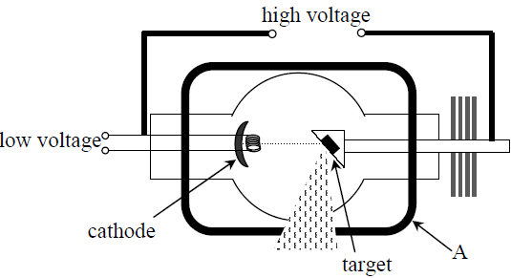What are X-rays?
2. State two properties of X-rays.
3. What process occurs at the cathode?
4. Name a substance commonly used as the target.
5. State the function of the part marked A.
6. State one use of X-rays.
7. A cathode ray tube, like the one used in the cathode ray oscilloscope, also uses a beam of high speed electrons.

Draw a sketch of a cathode ray tube suitable for use in an oscilloscope.

1. Why is a vacuum needed in both the X-ray tube and the cathode ray tube?
2. State one use of a cathode ray oscilloscope.

**2015 no.11**

Read the following passage and answer the accompanying questions.

Ernest Rutherford (1871–1937, Nobel Prize 1908) was a brilliant student from New Zealand who, thanks to a grant, moved to the glorious Cavendish Laboratory in Cambridge, full of hopes and ambitions. Later in his life he became a physics professor at the University of Manchester.

One day in 1909, in Manchester, he suggested to his collaborator Hans Geiger and to his student Ernest Marsden that they study the deflection of the so-called alpha-particles. These are positively charged helium ions produced by a radioactive source of radium bromide. This deflection occurs when the alpha-particles pass through a thin film of gold. Experiments of this kind had already been performed, and it had been observed that the alpha-particles are only slightly deflected when they cross the film.

The novelty of Rutherford’s suggestion was that he asked his collaborators to check if any alpha-particle bounced back instead of going through the film. Why should a thin metal film reflect heavy high-speed bullets, like the alpha-particles produced by a radioactive source? Geiger and Marsden made their measurement and ran back breathlessly to Rutherford. They had observed that some alpha-particles were indeed bouncing back.

In Rutherford’s words: “It was quite the most incredible event that has ever happened to me in my life”. He had looked inside the atom and the image he saw was very different from what physicists had expected. A central nucleus, much smaller than the actual size of the atom, holds the entire positive charge and practically all the atomic mass. The rest is just a cloud of light electrons, carrying all the negative charge.

(Adapted from *A Zeptospace Odyssey*, Gian Francesco Giudice, Oxford University Press, 2010)

(*a*) What are alpha-particles?

(*b*) Name a source of alpha-particles.

(*c*) What material was used as the target in the experiment?

(*d*) How did Geiger and Marsden detect the alpha-particles?

(*e*) What was the surprising result they observed?

(*f*) What force caused the deflection of the alpha-particles?

(*g*) Outline what the Geiger-Marsden experiment revealed about the structure of the atom.

(*h*) For what invention is Hans Geiger most famous?

**2015 no.12**

Answer any **two** of the following parts, (*a*), (*b*), (*c*), (*d*).

*a*)

A bicycle can be steered by applying a pair of equal but opposite forces to the handlebars, which act as a lever.

1. What is meant by the term *lever*?
2. What is the name given to the turning effect of a force?
3. What is the name given to a pair of equal but opposite forces?
4. A cyclist’s hands are placed 40 cm apart on the ends of the handlebars.

To turn the bicycle, he applies a force of 20 N through each hand.

Calculate the turning effect of the force.

*b)*

1. What is meant by dispersion of light?
2. What does dispersion of light indicate about the nature of white light?
3. Name two laboratory techniques that can be used to cause dispersion of light.
4. Describe one example of dispersion of light occurring in nature.
5. The diagram shows stage lighting similar to that found in most theatres.

Only red, green and blue lights are needed to create all the colours needed on stage.

Explain why this is so.

*c*)

1. Define resistance.
2. What is the unit of resistance?
3. Describe an experiment to demonstrate the heating effect of an electric current.
4. Electrical conduction in different materials is due to the movement of charge carriers.

State the charge carriers that are responsible for conduction in each of the following.

* gases
* semiconductors
* metals
* solutions

*d*)

A solenoid (long coil of wire) is connected to a battery as shown.

1. 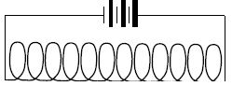Copy the diagram into your answer book and draw the magnetic field in and around the solenoid.
2. Explain the term *electromagnetic induction*.
3. A magnet and a solenoid can together be used to produce electricity.

Describe, with the aid of a diagram, how this can be done.